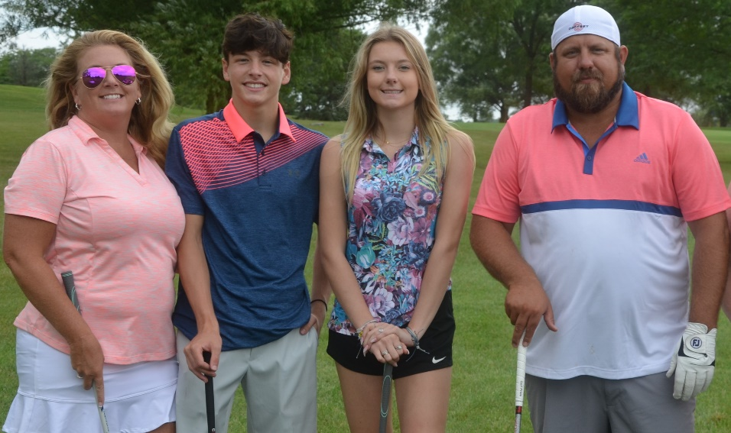
AshleyCan
Pediatric Cancer Foundation
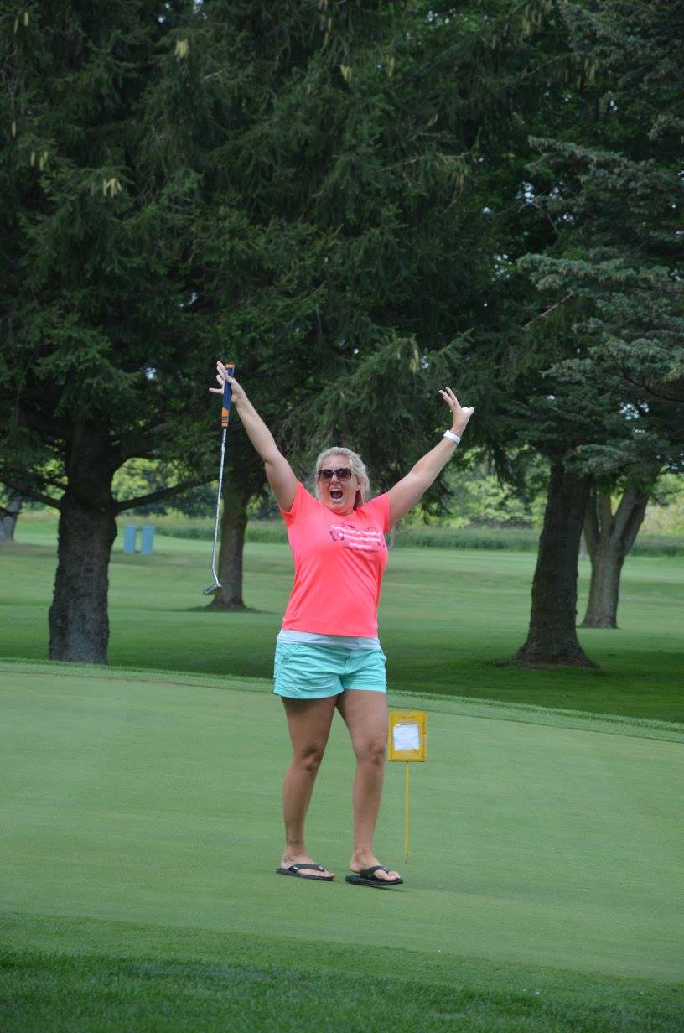
Charity Golf Outing
Contact:
Maureen Montgomery
815-922-4106
maureen.ashleycan@gmail.com
ashleycan.org

Sponsored by:
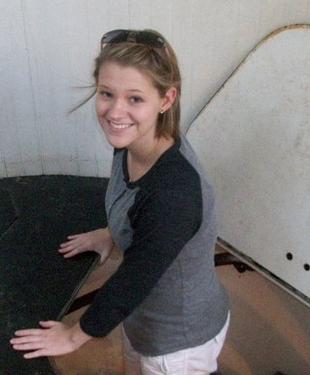
DATE: Saturday September 25, 2021
WHERE: Coyote Run Golf Course
800 Kedzie Ave
Flossmoor, IL 60422
TIME: 12:30 pm Registration
1:30 pm Modified Shotgun
COST: $150- Per Golfer
Teams of 4. Single Registrants will be put together to make a team
Come for Raffles & Dinner: $40
Living the Legacy Of
Fee Includes: Green Fee, Cart, Lunch Ashley Montgomery
2 Drink Tickets & Dinner, Games, Contests,
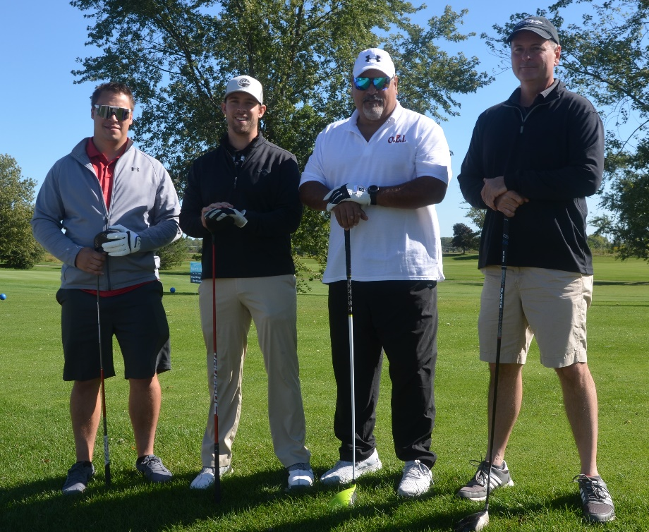
Raffles, 50/50, Door Prizes

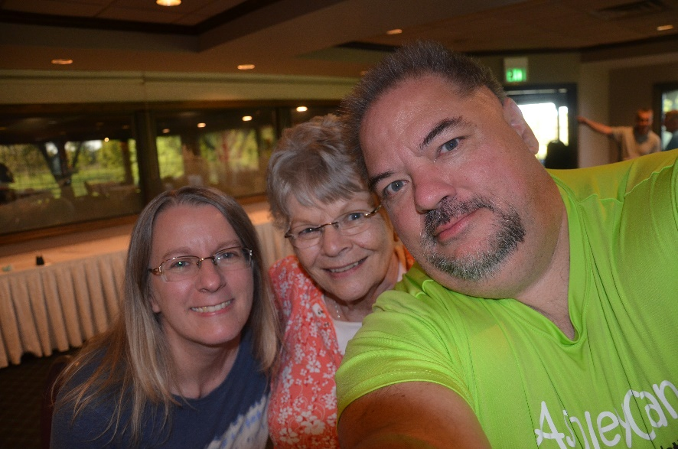
Remembering Steve O.

Registration:

Team Name: _____________________________________________________________

Team Members Names:

1.___________________________________________________________________________

2.___________________________________________________________________________

3.___________________________________________________________________________

4.___________________________________________________________________________

Waiver of Legal Liability
By signing below, I do hereby release and discharge from liability AshleyCan Pediatric Cancer Foundation,
the directors, organizers, sponsors, supervisors, volunteers of the event, and their representatives,
successors and assigns for all injuries suffered by me in this event, however incurred or sustained. I attest
and verify that I am physically fit and have sufficiently trained for the completion of this event if a running
event. Further, I hereby grant full permission to any and all the foregoing to use any photograph, video,
recording or any other record of this event for any purpose whatever. All events have a no refund policy.
The foundation will make one attempt to reschedule an event that is cancelled due to weather, if possible.

Golfer’s Signature

1.________________________________________________________________________________

2.________________________________________________________________________________

3.________________________________________________________________________________

4.________________________________________________________________________________

Make Checks Payable to AshleyCan. Mail to AshleyCan PO Box 6 Bourbonnais, IL 60914

